Class10: Halloween Candy Mini Project

Brittney Hayes

2024-02-12

# 1. Importing Candy Data

#Import candy data  
candy_data <- read.csv("https://raw.githubusercontent.com/fivethirtyeight/data/master/candy-power-ranking/candy-data.csv")   
candy_file <- candy_data

Q1. How many different candy types are in this dataset?

#Find how many candy types/brands there are  
dim(candy_file)

## [1] 85 13

#Count categories of candy types  
ncol(candy_file[2:10])

## [1] 9

There are 85 brands/types of candy and 9 categories/types, I omitted a few columns that were not specifying types of candy.

Q2. How many fruity candy types are in the dataset?

#Find sum of fruity candy  
sum(candy_file["fruity"])

## [1] 38

There are 38 fruity candy types.

# 2. What is your favorite candy?

Q3. What is your favorite candy in the dataset and what is it’s winpercent value?

#Find winpercent value of Snickers  
candy_file[65,]$winpercent

## [1] 76.67378

My favorite candy is Snickers and the winpercent value is 76.67378.

Q4. What is the winpercent value for “Kit Kat”?

#Find winpercent value of Kit Kat  
candy_file[29,]$winpercent

## [1] 76.7686

Q5. What is the winpercent value for “Tootsie Roll Snack Bars”?

#Calculate winpercent value of Tootsie Roll Snack Bars  
candy_file[78,]$winpercent

## [1] 49.6535

#install.packages("skimr")  
library("skimr")  
skim(candy_file)

Data summary

|  |  |
| --- | --- |
| Name | candy_file |
| Number of rows | 85 |
| Number of columns | 13 |
| _______________________ |  |
| Column type frequency: |  |
| character | 1 |
| numeric | 12 |
| ________________________ |  |
| Group variables | None |

**Variable type: character**

| skim_variable | n_missing | complete_rate | min | max | empty | n_unique | whitespace |
| --- | --- | --- | --- | --- | --- | --- | --- |
| competitorname | 0 | 1 | 4 | 27 | 0 | 85 | 0 |

**Variable type: numeric**

| skim_variable | n_missing | complete_rate | mean | sd | p0 | p25 | p50 | p75 | p100 | hist |
| --- | --- | --- | --- | --- | --- | --- | --- | --- | --- | --- |
| chocolate | 0 | 1 | 0.44 | 0.50 | 0.00 | 0.00 | 0.00 | 1.00 | 1.00 | ▇▁▁▁▆ |
| fruity | 0 | 1 | 0.45 | 0.50 | 0.00 | 0.00 | 0.00 | 1.00 | 1.00 | ▇▁▁▁▆ |
| caramel | 0 | 1 | 0.16 | 0.37 | 0.00 | 0.00 | 0.00 | 0.00 | 1.00 | ▇▁▁▁▂ |
| peanutyalmondy | 0 | 1 | 0.16 | 0.37 | 0.00 | 0.00 | 0.00 | 0.00 | 1.00 | ▇▁▁▁▂ |
| nougat | 0 | 1 | 0.08 | 0.28 | 0.00 | 0.00 | 0.00 | 0.00 | 1.00 | ▇▁▁▁▁ |
| crispedricewafer | 0 | 1 | 0.08 | 0.28 | 0.00 | 0.00 | 0.00 | 0.00 | 1.00 | ▇▁▁▁▁ |
| hard | 0 | 1 | 0.18 | 0.38 | 0.00 | 0.00 | 0.00 | 0.00 | 1.00 | ▇▁▁▁▂ |
| bar | 0 | 1 | 0.25 | 0.43 | 0.00 | 0.00 | 0.00 | 0.00 | 1.00 | ▇▁▁▁▂ |
| pluribus | 0 | 1 | 0.52 | 0.50 | 0.00 | 0.00 | 1.00 | 1.00 | 1.00 | ▇▁▁▁▇ |
| sugarpercent | 0 | 1 | 0.48 | 0.28 | 0.01 | 0.22 | 0.47 | 0.73 | 0.99 | ▇▇▇▇▆ |
| pricepercent | 0 | 1 | 0.47 | 0.29 | 0.01 | 0.26 | 0.47 | 0.65 | 0.98 | ▇▇▇▇▆ |
| winpercent | 0 | 1 | 50.32 | 14.71 | 22.45 | 39.14 | 47.83 | 59.86 | 84.18 | ▃▇▆▅▂ |

Q6. Is there any variable/column that looks to be on a different scale to the majority of the other columns in the dataset?

#Find variables of candy data  
library(skimr)  
skim(candy_file)

Data summary

|  |  |
| --- | --- |
| Name | candy_file |
| Number of rows | 85 |
| Number of columns | 13 |
| _______________________ |  |
| Column type frequency: |  |
| character | 1 |
| numeric | 12 |
| ________________________ |  |
| Group variables | None |

**Variable type: character**

| skim_variable | n_missing | complete_rate | min | max | empty | n_unique | whitespace |
| --- | --- | --- | --- | --- | --- | --- | --- |
| competitorname | 0 | 1 | 4 | 27 | 0 | 85 | 0 |

**Variable type: numeric**

| skim_variable | n_missing | complete_rate | mean | sd | p0 | p25 | p50 | p75 | p100 | hist |
| --- | --- | --- | --- | --- | --- | --- | --- | --- | --- | --- |
| chocolate | 0 | 1 | 0.44 | 0.50 | 0.00 | 0.00 | 0.00 | 1.00 | 1.00 | ▇▁▁▁▆ |
| fruity | 0 | 1 | 0.45 | 0.50 | 0.00 | 0.00 | 0.00 | 1.00 | 1.00 | ▇▁▁▁▆ |
| caramel | 0 | 1 | 0.16 | 0.37 | 0.00 | 0.00 | 0.00 | 0.00 | 1.00 | ▇▁▁▁▂ |
| peanutyalmondy | 0 | 1 | 0.16 | 0.37 | 0.00 | 0.00 | 0.00 | 0.00 | 1.00 | ▇▁▁▁▂ |
| nougat | 0 | 1 | 0.08 | 0.28 | 0.00 | 0.00 | 0.00 | 0.00 | 1.00 | ▇▁▁▁▁ |
| crispedricewafer | 0 | 1 | 0.08 | 0.28 | 0.00 | 0.00 | 0.00 | 0.00 | 1.00 | ▇▁▁▁▁ |
| hard | 0 | 1 | 0.18 | 0.38 | 0.00 | 0.00 | 0.00 | 0.00 | 1.00 | ▇▁▁▁▂ |
| bar | 0 | 1 | 0.25 | 0.43 | 0.00 | 0.00 | 0.00 | 0.00 | 1.00 | ▇▁▁▁▂ |
| pluribus | 0 | 1 | 0.52 | 0.50 | 0.00 | 0.00 | 1.00 | 1.00 | 1.00 | ▇▁▁▁▇ |
| sugarpercent | 0 | 1 | 0.48 | 0.28 | 0.01 | 0.22 | 0.47 | 0.73 | 0.99 | ▇▇▇▇▆ |
| pricepercent | 0 | 1 | 0.47 | 0.29 | 0.01 | 0.26 | 0.47 | 0.65 | 0.98 | ▇▇▇▇▆ |
| winpercent | 0 | 1 | 50.32 | 14.71 | 22.45 | 39.14 | 47.83 | 59.86 | 84.18 | ▃▇▆▅▂ |

Sugarpercent, pricepercent, and winpercent appear different.

Q7. What do you think a zero and one represent for the candy$chocolate column?

#View how many 0s and 1s chocolate has  
table(candy_file$chocolate)

##   
## 0 1   
## 48 37

The 0 and 1 confirm if the candy type falls into this candy, 0 means it does not/false and 1 means it does/true. So 0 is not chocolate and 1 is chocolate.

# 3. Overall Candy Rankings

Q8. Plot a histogram of winpercent values

#Plot histogram of winpercent values  
hist(candy_data$winpercent,   
 main = "Histogram of Winpercent Values",  
 xlab = "Winpercent",  
 ylab = "Frequency")

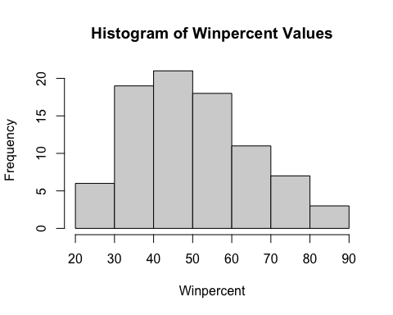

Q9. Is the distribution of winpercent values symmetrical? Based on the appearance of the histogram, no.

Q10. Is the center of the distribution above or below 50%?

#Find center of distribution  
mean(candy_file$winpercent)

## [1] 50.31676

median(candy_file$winpercent)

## [1] 47.82975

Based on the mean, it’s above 50% but by very little. Based on the median, it’s below 50% again by little. Based on the histogram it appears below 50%. So I would say below 50%.

Q11. On average is chocolate candy higher or lower ranked than fruit candy?

#Find average of chocolate candy ranking  
candy_file$winpercent[as.logical(candy_file$chocolate)]

## [1] 66.97173 67.60294 50.34755 56.91455 38.97504 55.37545 62.28448 56.49050  
## [9] 59.23612 57.21925 76.76860 71.46505 66.57458 55.06407 73.09956 60.80070  
## [17] 64.35334 47.82975 54.52645 70.73564 66.47068 69.48379 81.86626 84.18029  
## [25] 73.43499 72.88790 65.71629 34.72200 37.88719 76.67378 59.52925 48.98265  
## [33] 43.06890 45.73675 49.65350 81.64291 49.52411

mean(candy_file$winpercent[as.logical(candy_file$chocolate)])

## [1] 60.92153

#Find average of fruity candy ranking  
candy_file$winpercent[as.logical(candy_file$fruity)]

## [1] 52.34146 34.51768 36.01763 24.52499 42.27208 39.46056 43.08892 39.18550  
## [9] 46.78335 57.11974 51.41243 42.17877 28.12744 41.38956 39.14106 52.91139  
## [17] 46.41172 55.35405 22.44534 39.44680 41.26551 37.34852 35.29076 42.84914  
## [25] 63.08514 55.10370 45.99583 59.86400 52.82595 67.03763 34.57899 27.30386  
## [33] 54.86111 48.98265 47.17323 45.46628 39.01190 44.37552

mean(candy_file$winpercent[as.logical(candy_file$fruity)])

## [1] 44.11974

Chocolate candy is ranked higher than fruity candy on average.

Q12. Is this difference statistically significant?

#Perform t-test of chocolate and fruity candy  
chocolate <- candy_file$winpercent[as.logical(candy_file$chocolate)]  
fruit <- candy_file$winpercent[as.logical(candy_file$fruity)]  
  
t.test(chocolate,fruit)

##   
## Welch Two Sample t-test  
##   
## data: chocolate and fruit  
## t = 6.2582, df = 68.882, p-value = 2.871e-08  
## alternative hypothesis: true difference in means is not equal to 0  
## 95 percent confidence interval:  
## 11.44563 22.15795  
## sample estimates:  
## mean of x mean of y   
## 60.92153 44.11974

Since the p-value is less than 0.05, yes the difference is statistically significant.

Q13. What are the five least liked candy types in this set?

#Order candy types by least popular where n = 5  
head(candy_file[order(candy_file$winpercent),], n=5)

## competitorname chocolate fruity caramel peanutyalmondy nougat  
## 45 Nik L Nip 0 1 0 0 0  
## 8 Boston Baked Beans 0 0 0 1 0  
## 13 Chiclets 0 1 0 0 0  
## 73 Super Bubble 0 1 0 0 0  
## 27 Jawbusters 0 1 0 0 0  
## crispedricewafer hard bar pluribus sugarpercent pricepercent winpercent  
## 45 0 0 0 1 0.197 0.976 22.44534  
## 8 0 0 0 1 0.313 0.511 23.41782  
## 13 0 0 0 1 0.046 0.325 24.52499  
## 73 0 0 0 0 0.162 0.116 27.30386  
## 27 0 1 0 1 0.093 0.511 28.12744

The 5 least liked candy types are Nik L Nip, Boston Baked Beans, Chiclets, Super Bubble, and Jawbusters.

Q14. What are the top 5 all time favorite candy types out of this set?

#Order candy types by most popular where n = 5  
tail(candy_file[order(candy_file$winpercent),], n=5)

## competitorname chocolate fruity caramel peanutyalmondy nougat  
## 65 Snickers 1 0 1 1 1  
## 29 Kit Kat 1 0 0 0 0  
## 80 Twix 1 0 1 0 0  
## 52 Reese's Miniatures 1 0 0 1 0  
## 53 Reese's Peanut Butter cup 1 0 0 1 0  
## crispedricewafer hard bar pluribus sugarpercent pricepercent winpercent  
## 65 0 0 1 0 0.546 0.651 76.67378  
## 29 1 0 1 0 0.313 0.511 76.76860  
## 80 1 0 1 0 0.546 0.906 81.64291  
## 52 0 0 0 0 0.034 0.279 81.86626  
## 53 0 0 0 0 0.720 0.651 84.18029

The top 5 all time favorite candy types are Reese’s Peanut Butter cup, Reese’s Miniatures, Twix, Kit Kat, and Snickers.

Q15. Make a first barplot of candy ranking based on winpercent values.

#install.packages("ggplot2")  
library(ggplot2)  
  
#Make a ggplot of candy data  
ggplot(candy_file) +   
 aes(x = winpercent, y = rownames(candy_file)) +  
 geom_bar(stat = "identity", fill = "grey") +  
 labs(x = "winpercent", y = "competitorname") +  
 geom_text(aes(label=competitorname), vjust=-0.1, size=2) +  
 theme_minimal()

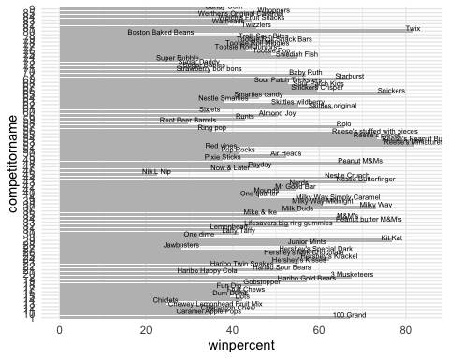 Q16. This is quite ugly, use the reorder() function to get the bars sorted by winpercent?

#Make a ggplot of candy data reordered  
library(ggplot2)  
  
ggplot(candy_file) +   
 aes(x = winpercent, y = rownames(candy_file)) +  
 geom_bar(stat = "identity", fill = "grey") +  
 labs(x = "winpercent", y = "competitorname") +  
 geom_text(aes(label=competitorname), vjust=-2, size=1) +  
 theme_minimal() + aes(winpercent, reorder(rownames(candy_file),winpercent))

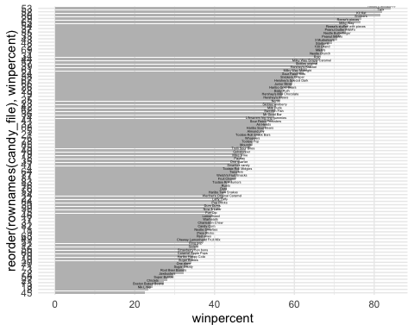

Sorted with color:

# Plot using colors  
candy <- candy_file  
my_cols=rep("black", nrow(candy))  
my_cols[as.logical(candy$chocolate)] = "chocolate"  
my_cols[as.logical(candy$bar)] = "brown"  
my_cols[as.logical(candy$fruity)] = "pink"  
  
ggplot(candy) +   
 aes(x = winpercent, y = rownames(candy)) +  
 geom_bar(stat = "identity", fill = "grey") +  
 labs(x = "winpercent", y = "competitorname") +  
 geom_text(aes(label=competitorname), vjust=-2, size=1) +  
 theme_minimal() + aes(winpercent, reorder(rownames(candy),winpercent)) + geom_col(fill=my_cols)

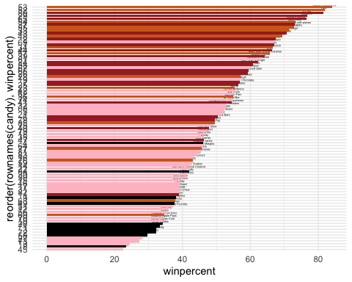

Q17. What is the worst ranked chocolate candy? The worst ranked chocolate candy is Sixlets.

Q18. What is the best ranked fruity candy? The best ranked fruity candy is Starburst.

# 4. Taking a Look at Pricepercent

#install.packages("ggrepel")  
library(ggrepel)  
  
# How about a plot of price vs win  
ggplot(candy) +  
 aes(winpercent, pricepercent, label=rownames(candy)) +  
 geom_point(col=my_cols) +   
 geom_text_repel(col=my_cols, size=3.3, max.overlaps = 5)

## Warning: ggrepel: 17 unlabeled data points (too many overlaps). Consider  
## increasing max.overlaps

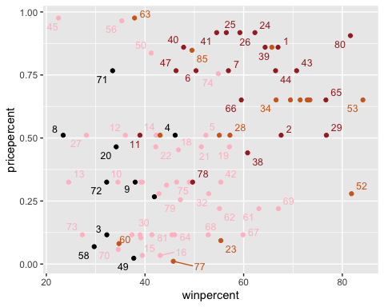

Q19. Which candy type is the highest ranked in terms of winpercent for the least money - i.e. offers the most bang for your buck?

52, which is Reese’s miniatures.

Q20. What are the top 5 most expensive candy types in the dataset and of these which is the least popular?

# Order candy by price and popularity  
ord <- order(candy$pricepercent, decreasing = TRUE)  
head( candy[ord,c(12,13)], n=5 )

## pricepercent winpercent  
## 45 0.976 22.44534  
## 63 0.976 37.88719  
## 56 0.965 35.29076  
## 24 0.918 62.28448  
## 25 0.918 56.49050

The top 5 most expensive candy types from most expensive to less expensive are Nik L Nip, Nestle Smarties, Ring Pop, Hershey’s Krackel, and Hersheys Milk Chocolate. The least popular of this group is Nik L Nip.

# Make a lollipop chart of pricepercent  
ggplot(candy) +  
 aes(pricepercent, reorder(rownames(candy), pricepercent)) +  
 geom_segment(aes(yend = reorder(rownames(candy), pricepercent),   
 xend = 0), col="gray40") +  
 geom_point() + geom_text(aes(label=competitorname), vjust=-2, size=1)

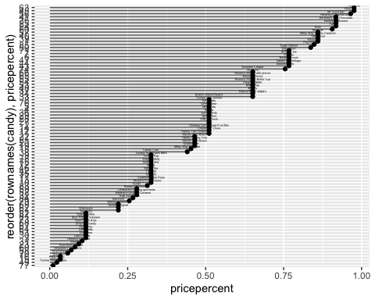

# 5. Exploring the Correlation Structure

#install.packages("corrplot")  
library(corrplot)

## corrplot 0.92 loaded

# Select only the numeric columns  
candy_numeric <- candy[, sapply(candy, is.numeric)]  
  
# Compute the correlation matrix  
cij <- cor(candy_numeric)  
  
# Plot the correlation matrix  
corrplot(cij)

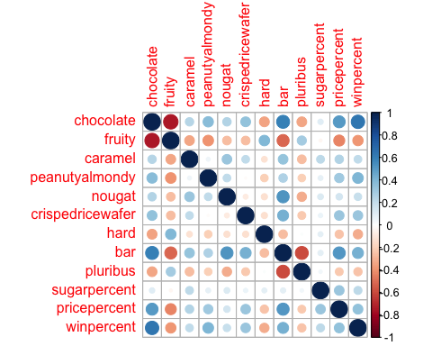

Q22. Examining this plot what two variables are anti-correlated (i.e. have minus values)?

Chocolate and fruity candy, pluribus and bar, fruity and bar, fruity and caramel, fruity and peanutyalmondy, fruity and nougat, fruity and crispedricewafer, fruity and pricepercent, fruity and winpercent, pluribus and caramel, pluribus and peanutyalmondy, pluribus and nougat, pluribus and crispedricewafer,bar and hard, hard and pricepercent, hard and winpercent, fruity and pricepercent, fruity and winpercent, pluribus and pricepercent, pluribus and winpercent.

Q23. Similarly, what two variables are most positively correlated?

Chocolate and winpercent; Chocolate and bar

# Principal Component Analysis

pca <- prcomp(candy_numeric, scale = TRUE)  
summary(pca)

## Importance of components:  
## PC1 PC2 PC3 PC4 PC5 PC6 PC7  
## Standard deviation 2.0788 1.1378 1.1092 1.07533 0.9518 0.81923 0.81530  
## Proportion of Variance 0.3601 0.1079 0.1025 0.09636 0.0755 0.05593 0.05539  
## Cumulative Proportion 0.3601 0.4680 0.5705 0.66688 0.7424 0.79830 0.85369  
## PC8 PC9 PC10 PC11 PC12  
## Standard deviation 0.74530 0.67824 0.62349 0.43974 0.39760  
## Proportion of Variance 0.04629 0.03833 0.03239 0.01611 0.01317  
## Cumulative Proportion 0.89998 0.93832 0.97071 0.98683 1.00000

plot our main PCA score plot of PC1 vs PC2

plot(pca$x[, c(1, 2)])

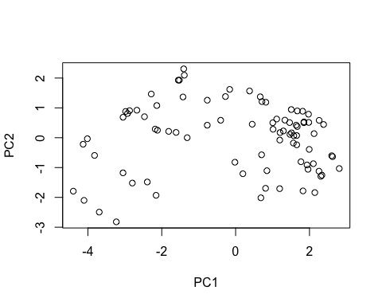

Change the plotting character and add some color

plot(pca$x[,1:2], col=my_cols, pch=16)

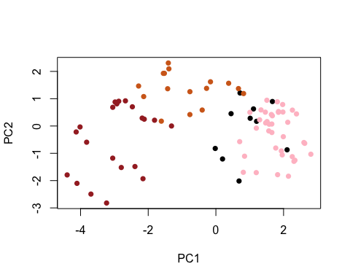

# Make a new data-frame with our PCA results and candy data  
my_data <- cbind(candy, pca$x[,1:3])

#Make ggplot  
p <- ggplot(my_data) +   
 aes(x=PC1, y=PC2,   
 size=winpercent/100,   
 text=rownames(my_data),  
 label=rownames(my_data)) +  
 geom_point(col=my_cols)  
  
p

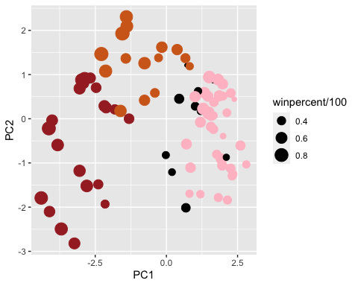

Apply ggrepel package

library(ggrepel)  
  
p + geom_text_repel(size=3.3, col=my_cols, max.overlaps = 100) +   
 theme(legend.position = "none") +  
 labs(title="Halloween Candy PCA Space",  
 subtitle="Colored by type: chocolate bar (dark brown), chocolate other (light brown), fruity (red), other (black)",  
 caption="Data from 538")

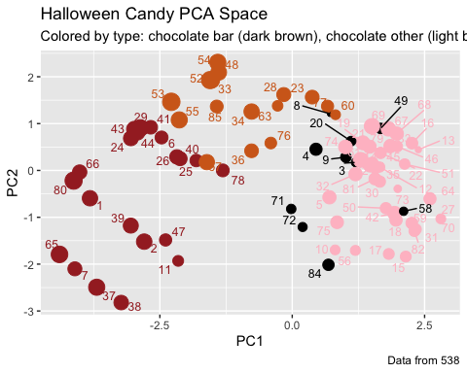

Pass the ggplot object p to plotly like so to generate an interactive plot that you can mouse over to see labels:

library(plotly)

##   
## Attaching package: 'plotly'

## The following object is masked from 'package:ggplot2':  
##   
## last_plot

## The following object is masked from 'package:stats':  
##   
## filter

## The following object is masked from 'package:graphics':  
##   
## layout

ggplotly(p)

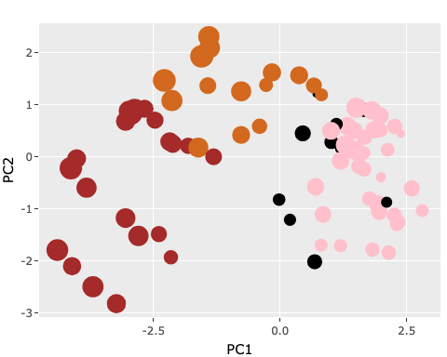

#Finish by taking a quick look at PCA our loadings.

par(mar=c(8,4,2,2))  
barplot(pca$rotation[,1], las=2, ylab="PC1 Contribution")

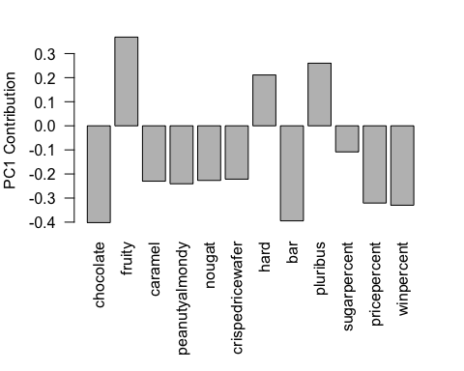

Q24. What original variables are picked up strongly by PC1 in the positive direction? Do these make sense to you?

Fruity, hard, and pluribus. Yes it makes sense.